**Route 53**

It is a DNS Service

It is to register our service in a DNS domain. It can be a aws or non-aws service

It is to provide an ip address when a user is trying to hit a domain name in web browser

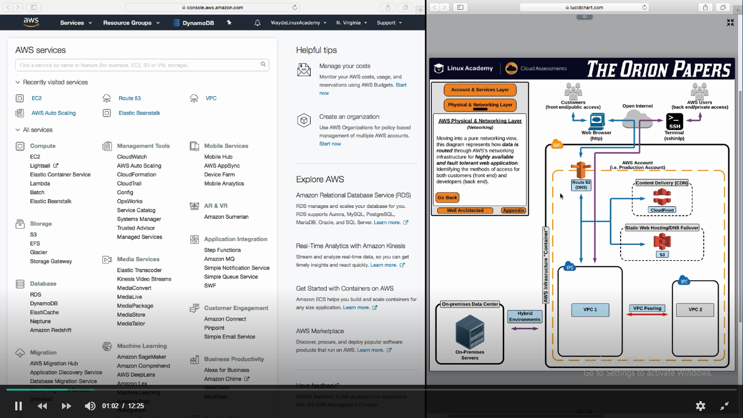

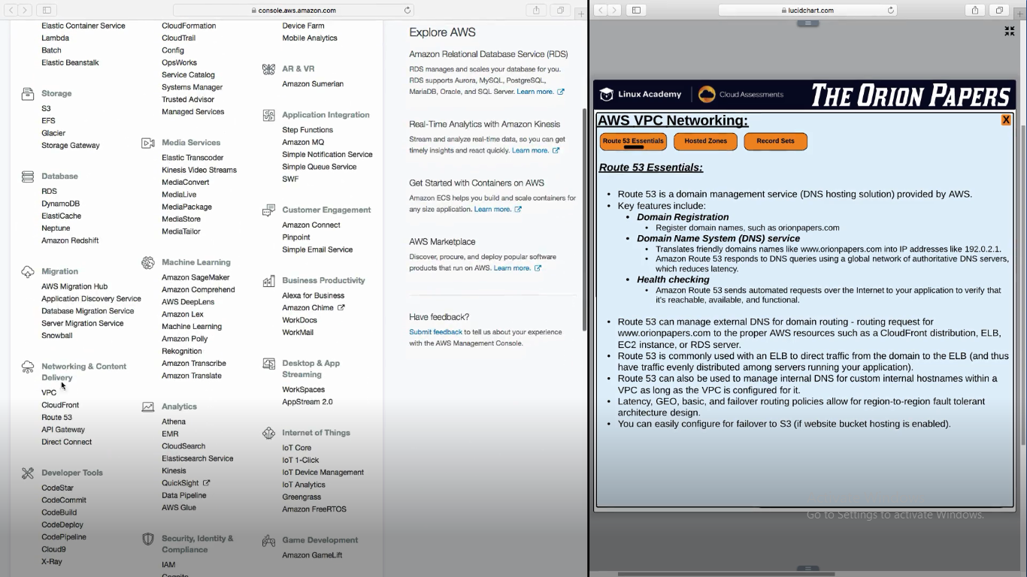

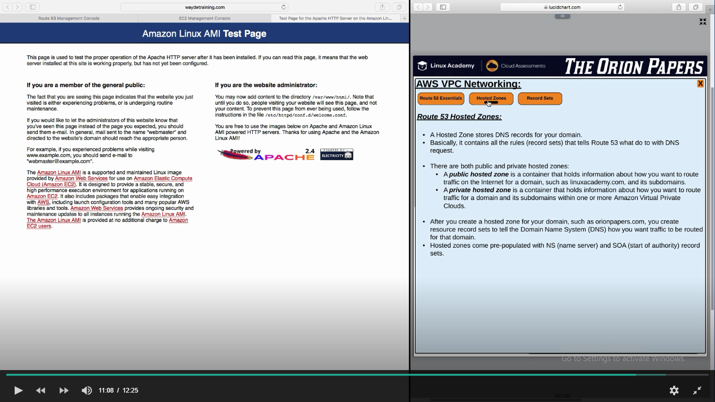

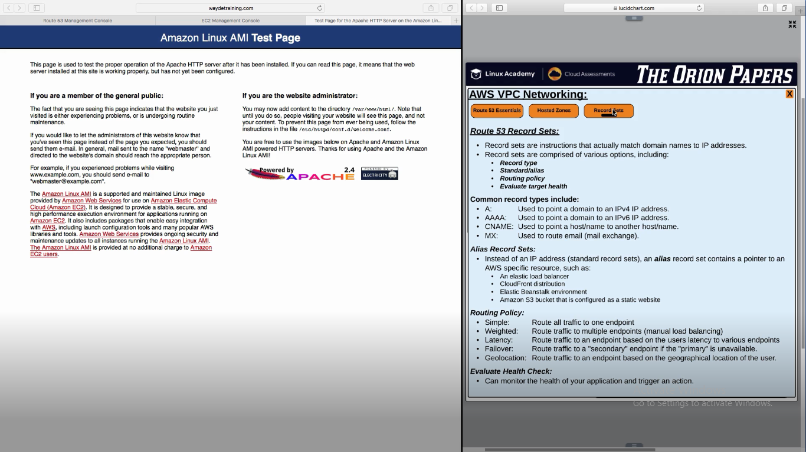

Networking and content delivery -> Route 53 -> Register Domain

Give a domain name and check if it is available

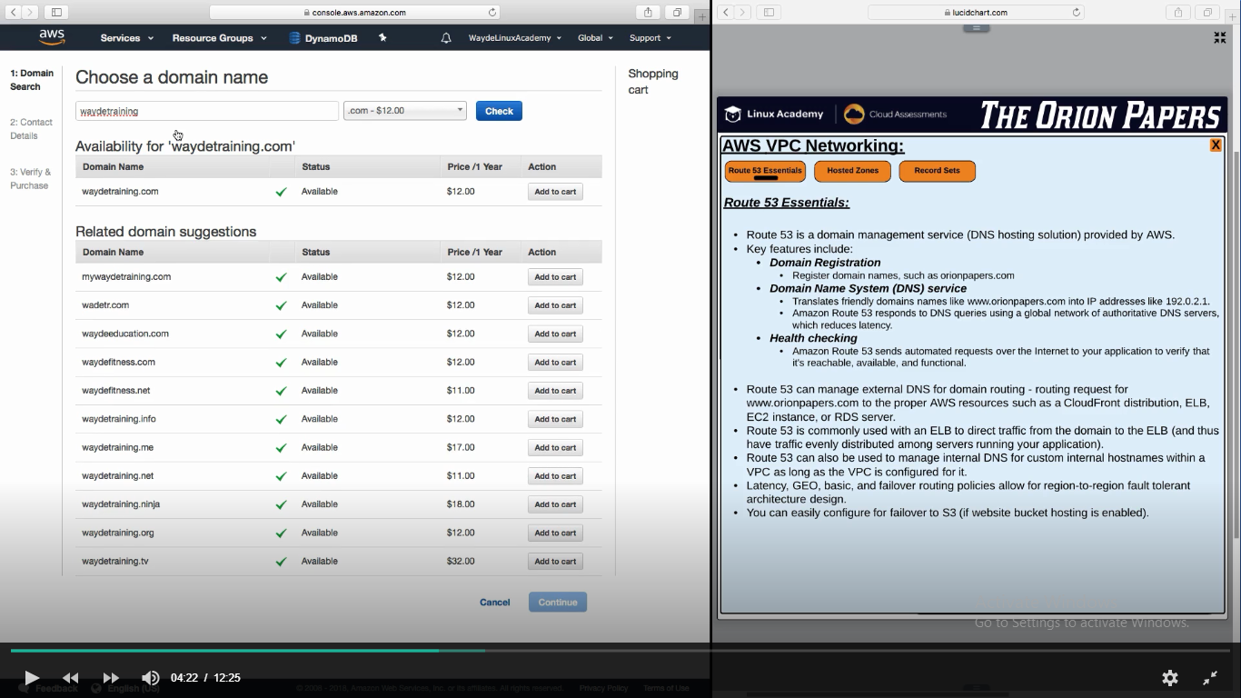

Next step is to fill the contact information’s and validate the email.

It takes around 50 min for the registration to get complete.

Once Completed go to hosted zone

Here we have to give our ip address which will respond when a use click on the domain name in web brosser

By default AWS will create below page for hosted zone. These are servers which will response to DNS request made by user

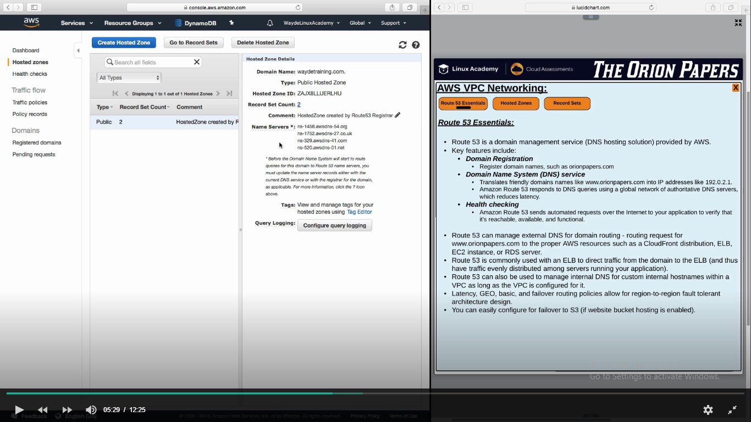

Hosted Zones -> Record Sets -> Create Record Sets

We have to set the alias

Give the dns name of the load balancer

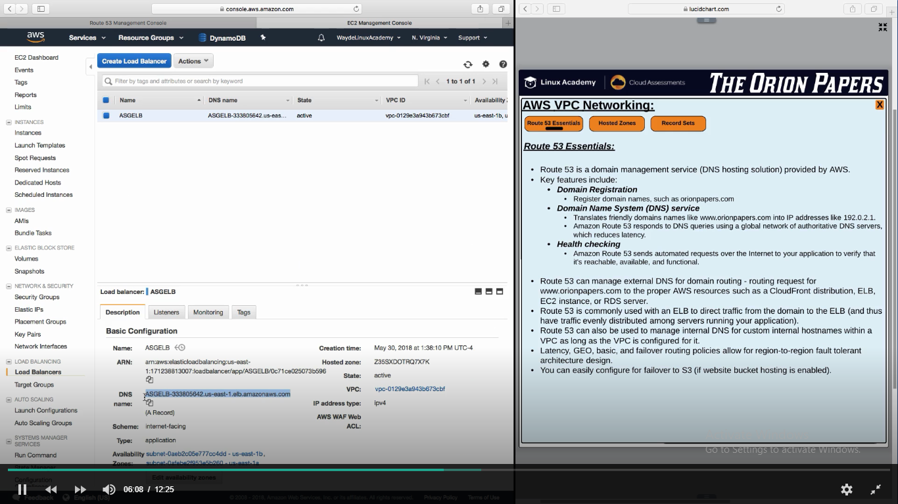

Routing Policy

**Simple** -> Go to load balancer

Weighted -> 2 or more endpoints. Divide the traffic by %

Useful when we test a new environment

**Latency** -> Multiple end points (if I have multiple load balancer dns name in multiple regions) direct the   
 call to the closest available region’s load balancer of the user

**Failover** -> if primary endpoint is not healthy, it directs the request to secondary endpoint

**GeoLocation** -> Direct endpoint based on user’s geography location.

If I access the endpoint from Asia, I will be routed to the endpoint available in asia regions

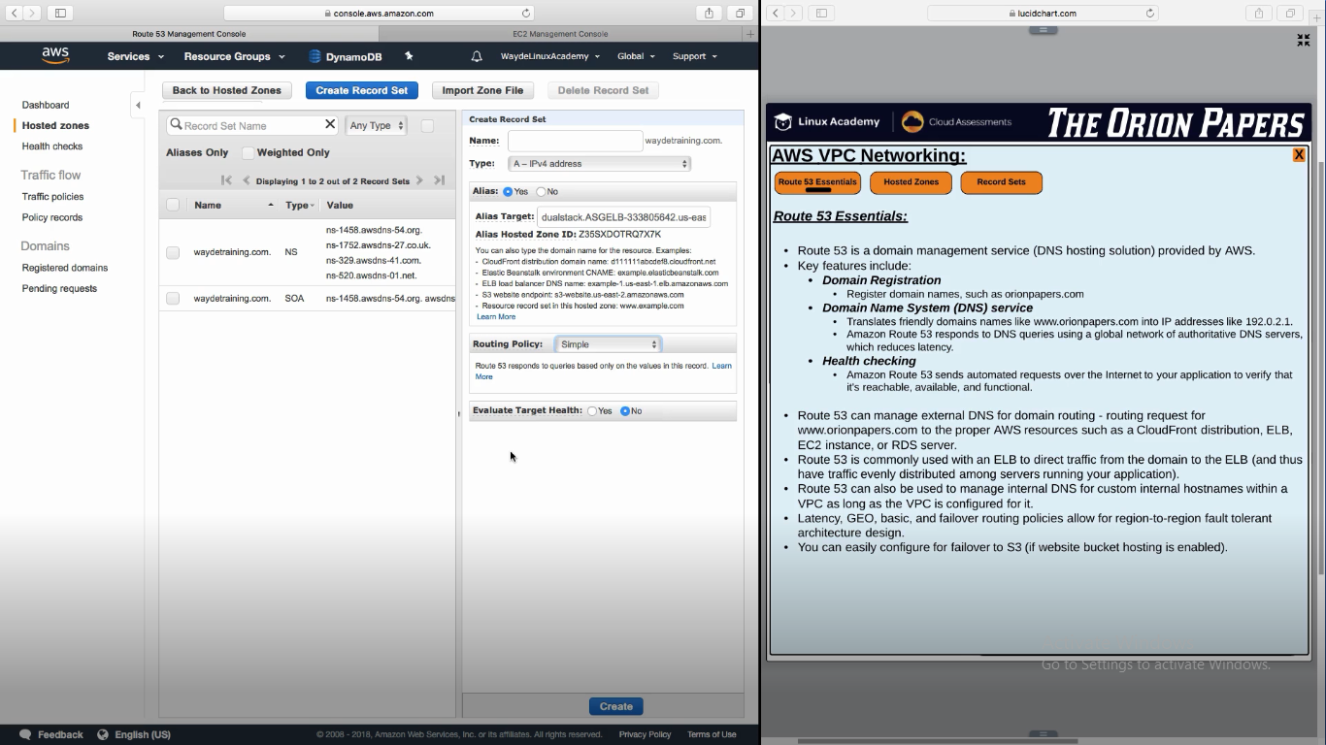

**Record Set Types**

A – points to an ip address (can be a load balancer)

C (CNAME – Canonical Name) – points to another domain. For example, [www.example.com](http://www.example.com) will route to [www.exampletest.com](http://www.exampletest.com)

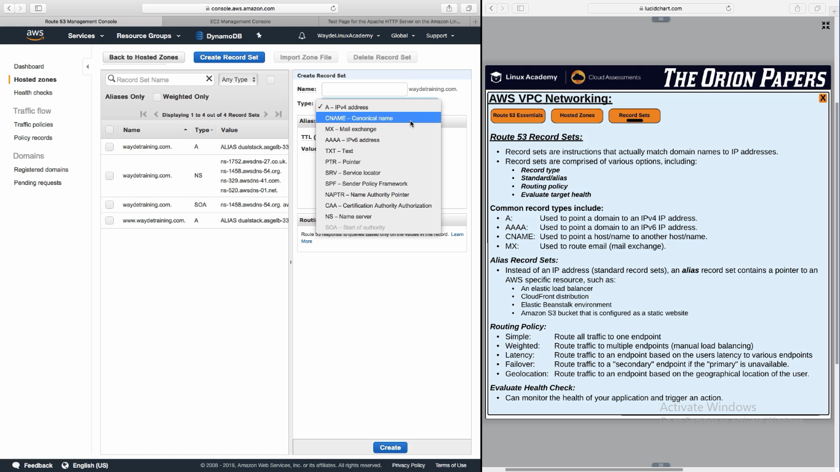

**Route 53 failover to S3 bucket**

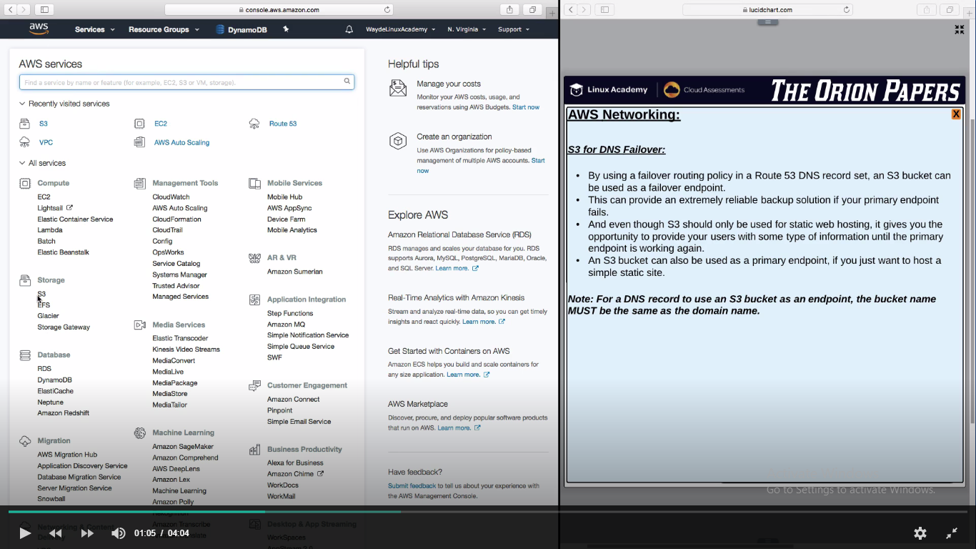

**S3 bucket files for failover content**

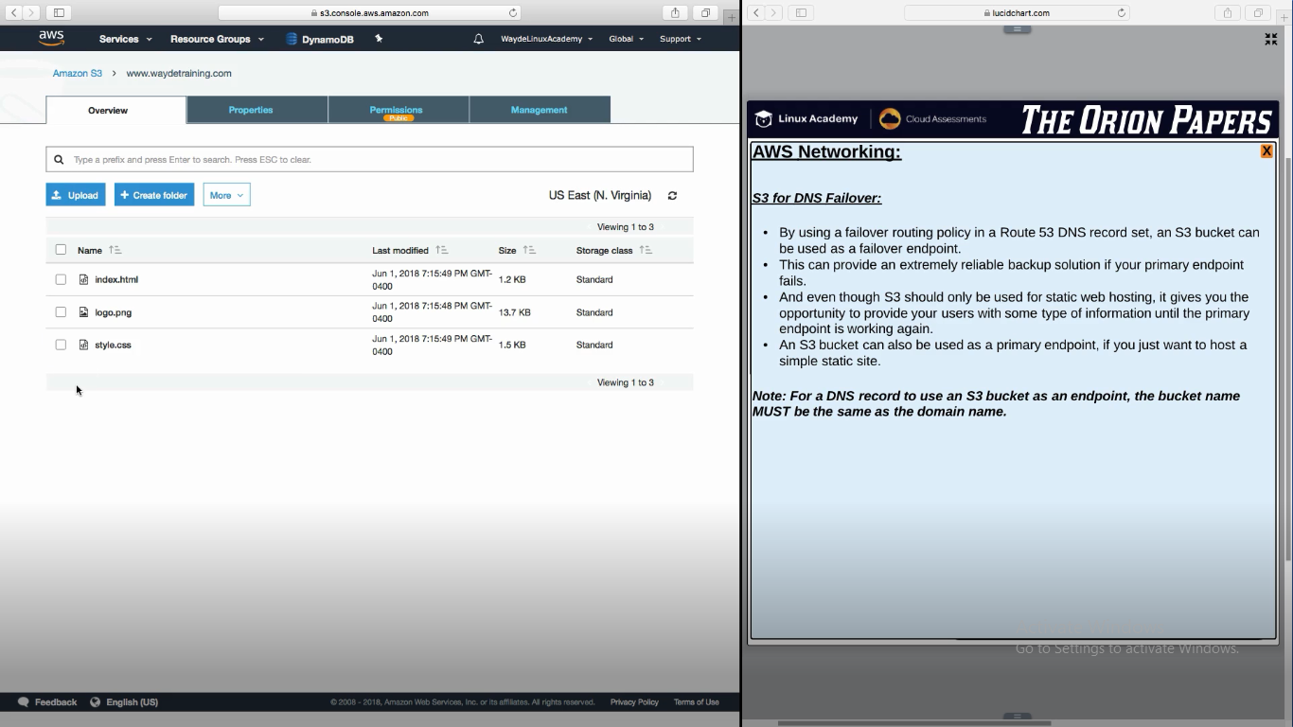

**Give this url in failover in Route 53**

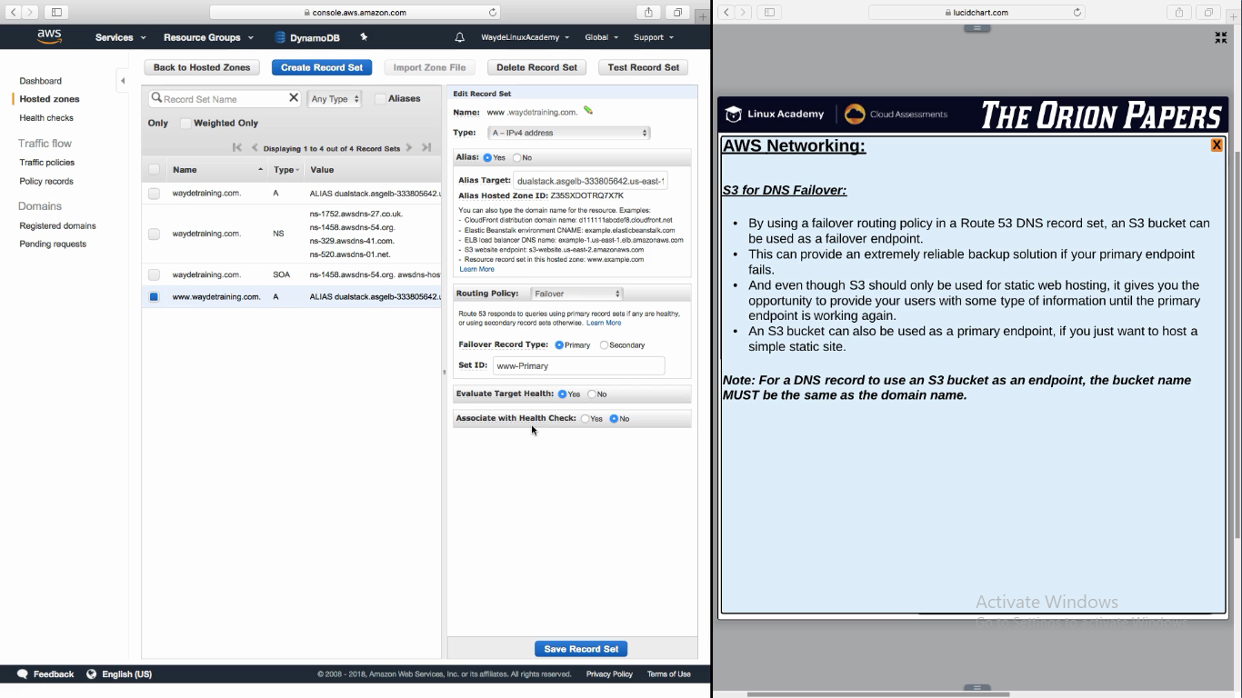

Evaluate Target Health – Inbuilt health check feature

Associate with health check – we can give our own health checks. Eg. Check if return string have a pattern

Create another record set for secondary – it will route the traffic to this s3 bucket if primary is down

